Schedule at a glance

|  |  |  |  |  |  |
| --- | --- | --- | --- | --- | --- |
| **SCHEDULE** | **Monday 13th** | **Tuesday 14th** | **Wednesd. 15th** | **Thursday 16th** | **Friday 17th** |
| 09h00 – 12h30 | - | Network School | Network Meeting | Network Workshop | Network Workshop  (**End of this session: 12h00**) |
| 12h30 – 13h30 | Buffet | Buffet | Lunch/Buffet | Lunch/buffet | Lunch/buffet |
| 13h30 – 18h00 | Network School | Social event | Supervisory Board | Network Workshop | - |
| 19h00 - 22h00 | Dinner | Dinner | Dinner | Dinner | - |

Expected number of participants

|  |  |  |  |  |  |
| --- | --- | --- | --- | --- | --- |
| **PARTICIPANTS** | **Monday** | **Tuesday** | **Wednesday** | **Thursday** | **Friday** |
| SEPOMO PhD students | 15 | 15 | 15 | 15 | 15 |
| (Co-)Supervisors (excl. SC + 2 internal lecturers) | 12 | 12 | - | - | - |
| 1 Scientific Coordinator (SC) | 1 | 1 | 1 | 1 | 1 |
| 1 European Project Manager EPM) | 1 | 1 | 1 | 1 | 1 |
| Lecturer(s) (from SEPOMO) | 2 | 2 | 2 | 2 | 2 |
| Lecturer(s) (external) | 2 | 2 | - | 2 | 2 |
| Supervisory Board members (excl. SC + ESRs + EPM) | - | - | 11 | - | - |
| Advisory Committee | 3 | 3 | 3 | - | - |
| Partner organisations | 2 | 2 | 2 | - | - |
| Other | - | - | - | - | - |
| **TOTAL** | **38** | **38** | **35** | **21** | **21** |

HOTELS

Séjours & Affaires Angers Atrium

20 Rue de Rennes, 49100 Angers

+33 (0)2 41 05 15 00

Appart'City Angers

57 Rue de Rennes, 49000 Angers

+33 (0)2 36 81 32 87

Best Western Hôtel d’Anjou

1 Boulevard du Maréchal Foch, 49100 Angers

+33 (0)2 41 21 12 11

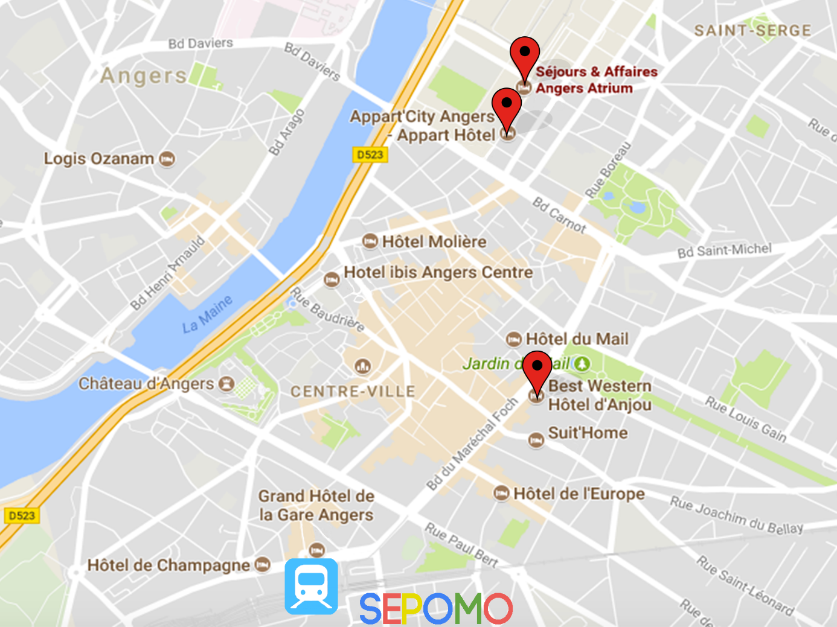

DISTRIBUTION IN HOTELS







SUNDAY 12 NOVEMBER 2017

20H00

DINNER FOR EARLY ARRIVALS

“Brasserie de la gare”

7 Place de la Gare, 49100 Angers

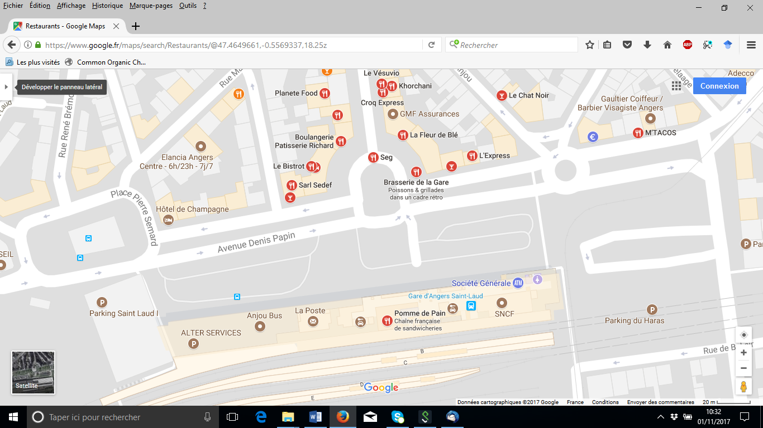

MONDAY 13 NOVEMBER 2017

MORNING

FOR EARLY ARRIVALS

10H30

DEPARTURE FROM HOTELS TO THE SCIENTIFIC CAMPUS

Tramway (Line A, dir: “La Roseraie”, stop at: “Ralliement”)

and City bus 1 (dir: “Belle-Beille”, from “République”, stop at “IUT”)

Faculty of Sciences of the University of Angers

2 boulevard Lavoisier, 49045 Angers

11H15 – 12H00

“Fast” LABTOUR of MOLTECH-Anjou

12H00 – 13H30

BUFFET SEPOMO-LUMOMAT

(Building L)

MONDAY 13 NOVEMBER 2017

AFTERNOON

NETWORK SCHOOL (Joint School with LUMOMAT)

Faculty of Sciences - University of Angers

2 boulevard Lavoisier, 49045 Angers

Amphitheatre L002 (Building L)

Chairman: Pr. Denis Jacquemin (University of Nantes)

13:30 – 13:50 Welcome & Introduction

*- Pr. Philippe Leriche, Dean of the faculty of Sciences*

*- Pr. Denis Jacquemin, co-Director of LUMOMAT*

*- Dr. Maxim Pchenitchnikov, SEPOMO Coordinator, Groningen*

- *Dr. Philippe Blanchard, MOLTECH-Anjou*

13:50 – 14:50 “Modeling spin effects in organic photovoltaics”

*by Pr. David Beljonne, University of Mons*

14:50 – 15:50 “Band-gap tuning of organic semiconductor polymers through intrachain heteroatom interactions”

*by Pr. Peter Skabara, University of Strathclyde*

15:50 – 16:15 Coffee break

Chairman: Dr. Clément Cabanetos (CNRS – University of Angers)

16:15 – 17:15 “The synthetic logic in the preparation of donor conjugated polymers for OPV”

*by Pr. Gianluca Farinola, University of Bari*

17:15 – 17:45 “Fullerenes in OPV: Still a long story ?”

*by Pr. Piétrick Hudhomme, University of Angers*

17:45 – 18:15 “Merck’s vision for OPV”

*by Dr. Agnieszka Pron (MERCK)*

18:30 Departure for Hotels

19H45 DINNER

“Brasserie du théâtre”, 7 Place du Ralliement, 49000 Angers

TUESDAY 14 NOVEMBER 2017

MORNING

NETWORK SCHOOL (Joint School with LUMOMAT)

Faculty of Sciences - University of Angers

2 boulevard Lavoisier, 49045 Angers

Amphitheatre L002 (Building L)

Chairman: Pr. Moritz Riede (University of Oxford)

09:00 – 10:00 “Structure-property-device performance relationships in organic and hybrid solar cells”

*by Pr. Peter Bäuerle, University of Ulm*

10:00 – 11:00 “Physics of Organic Photovoltaics: Current Status and Challenges”

*by Pr. Koen Vandewal, University of Dresden*

11:00 – 11:15 Coffee break

Chairman: Dr. Maxim S. Pchenitchnikov (University of Groningen)

11:15 – 11:45 “Vacuum processed OPV on its way from the lab to the field” *by Dr. Karsten Walzer, HELIATEK, Dresden*

11:45 – 12:45 “On the Role of Spin States in Charge Transfer Reactions in Organic Semiconductors and Devices”

*by Pr. Vladimir Dyakonov, University of Würzburg*

12H45 – 14H00

BUFFET SEPOMO-LUMOMAT

(Building L, “*Rez de Jardin*” room)

TUESDAY 14 NOVEMBER 2017

AFTERNOON

SOCIAL EVENT:

Visit of the Castle of Angers and Cointreau

14:30 Bus departure from the faculty of sciences to the Castle of Angers (City Center). Guided visit in English.

16:30 Bus departure from the Castle to the Cointreau Factory. Guided visit in English and tasting.

18:30 Back in town

19h45 DINNER

“Provence Caffé”, 9 Place du Ralliement, 49000 Angers

WEDNESDAY 15 NOVEMBER 2017

MORNING

NETWORK MEETING

Faculty of Law and Economics, University of Angers

13 allée F.Mitterand, 49100 Angers (Close to the Hotels)

Amphitheatre Sienne

09:00 – 10:30 Introductory presentations by each host organization

University of Groningen, NL

University of Oxford, UK

Technical University of Chemnitz, DE

Julius-Maximilians Universitaet Wuerzburg, DE

University of Mons, BE

Technical University of Dresden, DE

Heliatek GmbH, DE

Agencia Estatal Consejo Superior De Investigaciones Cientificas, M.P., ES

Université d'Angers, FR

Merck Chemicals LTD, UK

Fundacio EURECAT, ES

10:30 – 10:45 Coffee break (“Espace co-working”)

10:45 – 12:15 Introductory presentations by each ESR

ESR1 – Benedito Raul (Groningen)

ESR3 – Alberto Privitera (Oxford)

ESR4 – Maria Saladina (Chemnitz)

ESR5 – Ljudmilla Kudriashova (Wuerzburg)

ESR7 – Giacomo Londi (Mons)

ESR9 – Lukasz Baisinger (Dresden)

ESR11 – Rana Abdelaleim (Eurecat)

ESR12 – Francesco Silvestri (CSIC)

ESR13 – José María Andres Castan (Angers)

ESR14 – Pablo Simon Marques (Angers)

ESR15 – Pierluigi Mondelli (Merck)

12H30 – 13H30

BUFFET “Espace co-working”

WEDNESDAY 15 NOVEMBER 2017

AFTERNOON

SUPERVISORY BOARD

Faculty of Law and Economics - University of Angers

13 allée F.Mitterand, 49100 Angers

“Salle du Conseil”

*FREE AFTERNOON FOR OTHER SEPOMO MEMBERS AND ESRs*

13:30 – 14:00 WP5 Recruitment & Training

* Recruitment results and progress
* Supervision (TSPs/PCDPs)
* Secondments
* NWE2, Dresden – planning and organization

14:00 – 14:30 WP6 Management

* Consortium Agreement
* Financial plan
* Progress Report
* Advisory Board

14:30 – 14:45 WP7 Dissemination, Exploitation & Outreach

* (Planned) activities
* Joint budget plan

14:45 – 15:30 WP8 Research Data Management

15:30 – 15:45 WP9 Ethics

15:45 – 16:15 Coffee break (“Espace co-working”)

16:15 – 17:00 Scientific progress (WP1, WP2 and WP4)

17:00 – 18:00 Other agenda points / additional discussion time

19H45 DINNER

“Brasserie du théâtre”, 7 Place du Ralliement, 49000 Angers

THURSDAY 16 NOVEMBER 2017

NETWORK WORKSHOP: ACADEMIC SKILLS

Faculty of Law and Economics

University of Angers

13 allée F.Mitterand, 49100 Angers

“Salle du Conseil”

*by* Björn Kriete and Maxim Pchenitchnikov

09:00 – 10:30 General introduction; Literature search

10:30 – 11:00 Coffee break

11:00 – 12:30 Academic integrity

12H30 – 13H30

BUFFET

13:30 – 15:30 Academic writing

15:30 – 16:15 Coffee break

16:15 – 18:00 Presentation skills

19H30 DINNER

“Chez Rémi”, 5 Rue des 2 Haies, 49100 Angers

FRIDAY 17 NOVEMBER 2017

MORNING

NETWORK WORKSHOP: ACADEMIC SKILLS

Faculty of Law and Economics

University of Angers

13 allée F.Mitterand, 49100 Angers

“Espace co-working” or Amphi Sienne

*by* Björn Kriete and Maxim Pchenitchnikov

09:00 – 10:30 Figure making

10:30 – 10:45 Coffee break

11:00 – 12:00 Presentation delivery

12H00 – 13H00

PACKED LUNCHES

13:00 Departures